**Department of Electrical and Computer Engineering**

**North South University**

**Senior**

**Design**

**Project**



**Integrated Industrial Monitoring and Protection System**

**Saif Ahmed Chowdhury ID # 1410773043**

**Md Shahriyar Uddin ID # 1330437043**

**Tahmid Kamal ID # 1330339043**

**Rabiul Islam Sikder ID # 1410926043**

Faculty Advisor:

Dr. Mahdy Rahman Chowdhury

Associate Professor

ECE Department

Spring, 2018

Declaration

This is to certify that this Project is solely done by us and it’s our original work. The whole project is completed with the contribution of our group members and no part of this work is submitted anywhere else partially or fully for any award in other degree or diploma. Any material reproduced in our project has been properly acknowledged.

Student’s name & signature

1. **Saif Ahmed Chowdhury**

………………………………………….

**2) Md Shahriyar Uddin**

……………………………………

**3) Tahmid Kamal**

…………………………………………

**4) Rabiul Islam Sikder**

…………………………………………

# Approval

We, **Saif Ahmed Chowdhury**(ID# 1410773043), **Md Shahriyar Uddin**(ID# 1330437043) and **Tahmid Kamal** (ID# 1330339043) **Rabiul Islam Sikder** (ID# 1410926043), members of EEE/ETE: 499 (Senior Design) from the Electrical and Computer Engineering department of **North South University**; have worked on the project titled **“Integrated Industrial Monitoring and Protection System”** under the supervision of Dr.Mahdy Rahman Chowdhury as a partial fulfillment of the requirement for the degree of Bachelors of Science in Engineering and has been accepted as satisfactory.

**Supervisor**’**s Signature**

…………………………………….

**Dr. Mahdy Rahman Chowdhury**

**Assistant Professor**

Department of Electrical & Computer Engineering

North South University

Dhaka, Bangladesh.

**Chairman**’**s Signature**

…………………………………….

Dr. Shazzad Hosain

Associate Professor

Department of Electrical & Computer Engineering  
North South University  
Dhaka, Bangladesh

# Acknowledgement

It is with pleasure and pride that we would like to formally declare the completion of our EEE 499 Senior Design Project entitled “Integrated Industrial Monitoring and Protection System”.

We would like to display our utmost gratitude to Dr. Mahdy Rahman Chowdhury for his constant support, motivation, and brilliant insights throughout the duration of 499A and 499B courses. His exhaustive efforts to provide feedback on iteratively design improvements immensely helped us to not only fine tune our project but also integrate novel features into it.

We would also like to express our sincere gratitude to Department of Electrical and Electronic engineering for providing us with valuable information and resources pertinent to our project. Furthermore, we also like to appreciate constructive criticism of our classmates that allowed us to work on the limitations of our project.

Lastly it would be incomplete without expressing our profound gratitude to our parents, who provided unfailing support and encouragement throughout the more difficult phases of the project. Such accomplishment would surely not have been possible without them.

Contents

Declaration 2

Approval 3

Acknowledgement 4

Appendix A 6

Chapter 1 8

Overview 9

Chapter 2 11

Literature Review 12

Chapter 3 18

Design Approach 19

Chapter 4 38

Performance Estimates and Evaluation 39

Chapter 5 44

Design Impact 45

Chapter 6 47

Discussion and Feedback 48

Limitations 49

Future Work 50

Conclusion 51

References 53

Appendix B: List of Figureures 55

Appendix C: List of Tables 56

Appendix D: MATLAB Code 57

Appendix E: ARDUINO Code 59

Appendix F: Pyhton Code 71

Appendix G: Bill of Materials 75

# Appendix A

This page is intentionally kept blank

## Chapter 1

### Overview

#### Introduction

In Bangladesh industry hazard and worker safety has increasingly become a paramount issue. The recent debacle of Tazreen Garments, other various industrial accidents have resulted in loss of lives, livelihood of families but also created an image crisis in the wider global world.

This was the impetus for us to delve into the problem to tackle from its root and technology has armed us to do so. The objective was to develop a cost effective comprehensive monitoring system that not only detects various hazards such as fire, smoke but also monitor the heat stress of the worker. The conceptual idea was to design a framework that would able to address as much of these issues as possible within the boundaries of physical and technical possibilities.

In our endeavor to look into the solutions we have also delved on the health aspect as well. From field monitoring conducted by a team from BUET, it was observed that production spaces in Readymade Garments (RMG) were adversely impacted by excessively hot indoor environments, and yet thousands of workers toiling away their days doing production work-in these spaces. Such excessive indoor temperatures, much higher than the worker’s normal body temperature, have an adverse impact on physiological conditions potentially leading health risks.[1]

This has been an often-overlooked issue and often leads to unreported productivity loss in form of sick leave and other latent health effects. So, using extrapolated WGBT modeling we were able to device a monitoring system that would be able to report worker discomfort and also automatically regulate the indoor temperature by adjusting ventilation setting.

Our aim was to integrate all these features into one-in-all comprehensive monitoring and protection system that is not only cost effective but also modular and portable solution that can be configured according to the demand of its consumer.

#### Statement of the Problems

* Most industrial plants and small firms alike, depends on traditional method for fire safety procedures of a general alarm followed by an exit strategy that often is hindered by confusion and other administrative hurdles. There is a distinct lack of technological innovation that automates most of the issues.
* In recent years, due to lack of considerations of indoor thermal condition as well as increasing global temperature has led to rapid increase of heatstroke patients at workplace.
* Existing active ventilation strategies do not meet the thermal comfort needs of the workers with significant overheating. There is a significant case to be made for the differences in sliding and pivoting windows to provide ventilation.
* Any alteration to the ventilation system is done almost entirely by manual methods. This results in loss of productivity and valuable operating time for many garment industries.

## Chapter 2

### Literature Review

#### 2.1 Introduction

The garments industries in our country have not yet reached a lifetime of 30 years, and yet 76% of Bangladesh’s foreign income is earned from this sector. Bangladesh is also being tagged as the second largest apparel exporter in the world with a total export of USD $17.91 billion in the fiscal year 2010-2011. Readymade garments are of significant export item behind our country’s growth, yet the working conditions and fire safety measurements are not met up to the standard. Despite the number of initiatives taken to curtail the increased rate of fire accidents in the garment industry, the number of fire occurrences in this industry is evident.

The distressing part is that, the welfare of the garments factory workers is still not taken in account by their respective authorities. Bangladesh has successfully penetrated into the world market through the products of garments industries, and these products are produced by poor Bangladeshis, where majority are women. If we cannot take responsibility and ensure our worker’s safety and security, it would eventually lead us towards failure.

The workers are endangered by the risk of fire as anytime accidents can cause them disability or they even might lose their lives. So far, from the events of accidents occurred in garments in our country, it has always shown a correlation with fire. Outbreaks of fire in garments factories is no longer an unusual occurrence in our country and people had accepted it as their fortune. Each time, after any disaster we learn a lesson regarding adequate measurements for workers safety but seem to forget about them in later time.

People had been dying because of minimal concern with safety measurements until the overseas buyers called for cancellation of imports from Bangladesh, due to large number of deaths and injuries. It is matter of great disgrace that we had to be warned by the importers about the safety concern of our workers. Even today there are many garments factory owners who are less concerned about their workers safety issues.

#### 2.2 Fire Safety Protocol in the Garment Sector in Bangladesh

According to Bangladesh Fire Services and Civil Defense Authority (BFSCDA) regulations, every garment factory has to obtain a fire safety certificate initially from the regulators to start the business and this certification is to be renewed every month by a visiting inspector from BFSCDA. BFSCDA uses a checklist for the fire certification of the garment factories.

Most of the parameters on the checklist are ‘hard’ in nature, by which we mean that the safety parameter is ‘passed’ through construction or buying of equipment's. However, even after a garment factory is built to the fire specifications of BNBC-93, which ensures it passes the ‘hard’ parameter, safety on the factory floor can vastly differ due to different management practices. For example, in order to ensure ease of egress during an emergency, BNBC-93 stipulates a minimum corridor width of 1.1 m for a factory building with more than 50 occupants.

Figure 2.1.1 shows an example where the ‘hard’ parameter for corridor width is met during design and construction, but due to deficient management practices the corridor is occupied by piled up boxes which reduces the effective width of the corridor and makes the passing of hard parameter useless in practice.

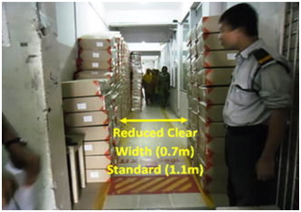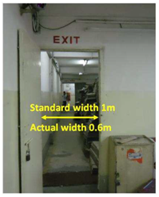

Figure 2.1.1 Clear width of an exit corridor reduced by piled up boxes

We call these management practice related parameters the ‘soft’ parameters, which can often have critical impact during a fire. Given the management practices (soft issues) are often as important as structural fire safety measures, yet difficult to regulate, this paper develops a fire risk index (FRI), the first of its kind in Bangladesh, for soft parameters in the garment industry.

FRI for 60 random garment factories are developed through surprise inspections to understand the current status of fire risk due to inadequacies in the soft parameters. Results show that the mean FRI is 2.8 on a scale of 5.0, which indicates an alarming condition. Locked exit doors, lack of emergency announcement system and lack of fire drills are the three worst performers among the 24 investigated parameters.

#### 2.3 Fire risk index (FRI)

|  |  |  |  |
| --- | --- | --- | --- |
| Rank | Parameters short name | Parameters description | Weight average |
| 1 | Locked exit | Locked/unlocked condition of exit door | 5.00 |
| 2 | Chemicals | Existence of chemical material inside | 4.75 |
| 3 | Block furniture | Blockade of exit corridor by furniture/other material | 4.75 |
| 4 | Fire drill | Practice of fire drill | 4.75 |
| 5 | Extinguisher workability | Serviceability of fire extinguisher | 4.63 |
| 6 | Water in tank | Presence of adequate water in tank | 4.63 |
| 7 | Extinguisher operator | Performance of fire extinguisher operator | 4.50 |
| 8 | Exposed utility inside | Exposed electric or gas line inside factory floor | 4.38 |
| 9 | Bottleneck corridor | Formation of bottleneck between corridor and exit door | 4.38 |
| 10 | Announcement | Workability of announcement system | 4.25 |
| 11 | Fire pump access | Accessibility to fire hydrant | 4.25 |
| 12 | Switch board | Location of main electric switch board | 4.13 |
| 13 | Communication | Communication between command centre to floor | 4.13 |
| 14 | Combustible | Presence of combustible item (cotton, cloth) inside | 4.00 |
| 15 | Fire pump protection | Protection of fire pump against mechanical damage | 4.00 |
| 16 | Occupant load | Number of workers/occupants per unit floor area | 3.88 |
| 17 | Roof access | Unobstructed access to the roof | 3.88 |
| 18 | On roof obstruction | Presence of obstruction on the roof | 3.75 |
| 19 | Emergency light | Serviceability/working condition of emergency lights | 3.75 |
| 20 | Electric overhead | Existence of electric overhead line in front of the building | 3.63 |
| 21 | Door swing | Outward/inward swinging of door | 3.63 |
| 22 | Alternate power | Presence of alternative power system | 3.63 |
| 23 | First aid | Availability of first aid kits on shop floor | 3.50 |
| 24 | Gas mask | Availability of gas mask for emergencies | 3.38 |

#### 2.4 Present scenario: Sign of improvement?

If we analyze, the past incidents and accidents, some terrible facts are revealed. In most cases, people died because of stampede. Why was the situation for a stampede created?

**Firstly**, workers are not trained (practice of fire drill).

**Secondly,** often the main gate is found locked. Finding the gate locked, workers try to run back up the stairs and run into others coming downstairs. This clash results into panic, an inevitable stampede, trampling, suffocation and death.

**Thirdly,** False fire alarms, sparking panic among untrained workers, are sometimes a cause for death. How tragic is this situation where people die of only panic and no fire!

**Fourth**, No provision for emergency lighting. And many other reasons for which thousands of peoples are dead and injured.

Some of the most tragic incident occurred in Bangladesh due to Fire, False Fire Alarm, and Gas Leakage**.**

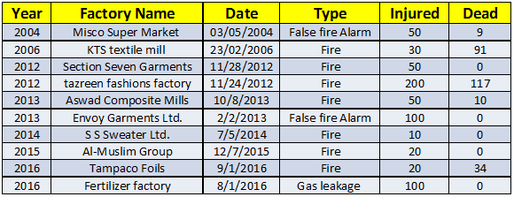

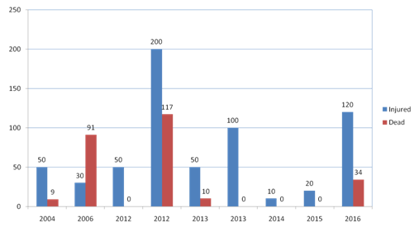

Figure 2.1.2: Death and Injured due to due to Fire, False Alarm and Gas leakage

#### 2.5 OSHA Compliance

The occupational health and safety service in Bangladesh is still in the developmental stage. Here the occupational health & safety refers mainly to needs of workers of industries or some manufacturing processes but does not completely cover all occupations of the country. The main laws related to occupational health & safety in this country is the Factory Act 1965 and the Factory Rule of 1979. There are a number of other laws and regulations that are also have some provisions related to occupational health and safety. These laws have provisions on occupational hygiene, occupational diseases, industrial accidents, protection of women and young persons in dangerous occupations and also cover conditions of work, working hours, welfare facilities, holidays, leave etc. But most of the laws are lacking in standard values and not specific rather general in nature. So it is imperative that we should set standards similar to OSHA (Occupational Safety and Health Administration) in our country ensure safety environment condition in industries.

In USA Occupational Safety and Health Administration (OSHA) are referred for the permissible levels or various standard limits for working environment. In Bangladesh no such organization or agencies have been developed which could be a referral center for different standard or occupational permissible limits. As such the prevalent rules and regulations in Bangladesh are insufficient or inadequate in terms of standards and permissible limits. Moreover, the enforcement department, the department of inspection, which is poor in quantity as well quality could not effectively enforce to improve the occupational safety and health in Bangladesh.

The Occupational Safety and Health Administration (OSHA) is an agency of the United States Department of Labor. Congress established the agency under the Occupational Safety and Health Act, which President Richard M. Nixon signed into law on December 29, 1970. OSHA's mission is to "assure safe and healthful working conditions for working men and women by setting and enforcing standards and by providing training, outreach, education and assistance".

The American Conference of Governmental Industrial Hygienists publishes threshold limit values (TLVs) that have been adopted by many governments for use in the workplace

## Chapter 3

### Design Approach

#### 3.1 Introduction

In this chapter we have noted down all the components we used for our project and gave a brief explanation of each and every component. We have also discussed how all these components were used in making the project. To keep our project as simple as possible at the same time accurate and operational we had to change our system design few times. Following components are the finalized version of our design.

#### 3.2 Block Diagram

First of all, we connected 3 white led on each floor. The leds in each floor are connected in parallel. Each led runs with a voltage of 4-5 volts but since we are supplying 5 volts so the led uses 5 volts. So, from each floor we get three parallel wires which is then connected to relays. So, with the help of the relays the leds are powered up. The relays are acting as a switch for three individual floors. All the components used in the building the circuit runs on 5 volts. The Arduino Uno 1 at a time cannot supply 5 volts to all the components. A buck converter is used to prevent the Arduino Uno 1 from being damaged. The input given in the buck converter is 9 volts and the output that is fed to the Arduino Uno 1 is 5 volts. And this 5 volts powers up all the components. Yellow colored led used in making the trail of light cannot be connected in series or in parallel. They must be connected separately. The negative terminal of all the yellow led is connected using common ground and the positive terminal is connected to Arduino Uno 2. The buzzer could be connected Arduino Uno 1 or 2, but Arduino Uno 2 was chosen so that it becomes independent and not have any delay.

In the Arduino code (given in Appendix E) we see that whenever the alarm(buzzer) goes on a pin is high. This high pin is connected to Arduino Uno 2 input. So Arduino Uno 2 basically monitors when it gets a high pin from Arduino Uno 1. When it receives the high pin it starts the buzzer and turns on the yellow leds. This is the communication between Arduino Uno 1 and 2. A voltage regulator is used to power up the GSM module. The voltage regulator converts the 9V adapter to 5V. Buck converter is responsible for powering Arduino Uno 1 and the components connected to it. And the voltage regulator is responsible for powering Arduino Uno 2 and the components connected to it. With the LCD display a potentiometer is connected to increase and decrease the contrast level. The following block diagram of the system gives us a clear view of 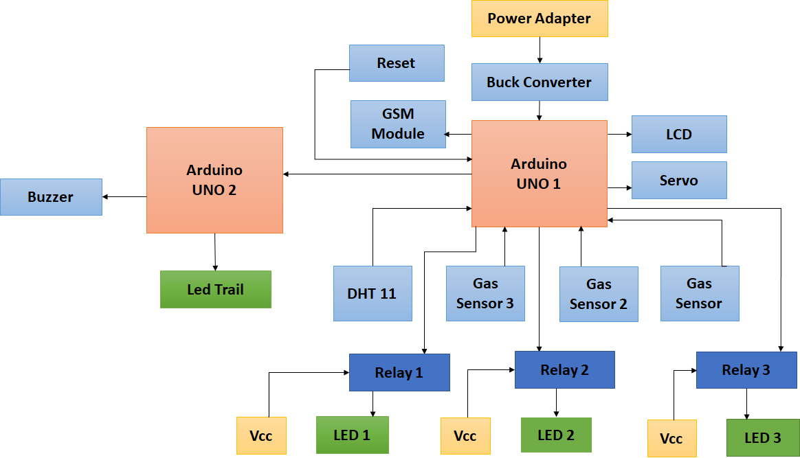how all the components are connected.

Figure.3.2.1 Block diagram of the system

#### 3.3 Conceptual Flow Chart

When we start the system the LCD display will display "Welcome". Then it will take some seconds to calibrate. The 16x2 LCD display will at all times display the current temperature, humidity and WBGT values. In our project we have provided three gas sensors for each floor. When the gas sensors detect some unwanted gas, the sensors are triggered. A message is displayed on the LCD showing from which floor the gas has been detected. A timeout of 10 seconds is provided to investigate if the message detected on the display is correct or not. If the message detected after the time out period has passed the power to that floor is switched off. This is done with the help of the relays. We have provided 3 relays each dedicated for each floor. Then another timeout of 15 seconds is provided. This timeout is provided to see that if the situation can be bought under control or not. After the second timeout has passed then, the power of the whole building will be cut off. Alarm will be turned on immediately then SMS will be sent to the authority and to the nearest fire brigade. As soon as the power is shut down a trail of light will appear on the ceiling directing to the exit door. This is down so that the people trapped in the room can find the route to the exit door with less complication. The above process is followed for the other two floors.

The temperature and humidity will be measured and monitored at all times. The measured values are then put in an algorithm that calculates the value of the WBGT. The current values of the WBGT are then compared with 3 ranges of values that is stored in the algorithm. When the current values exceed the stored values ventilation will be provided. Tilted window system is provided for ventilation. The angle to how much the window should be tilted depends on the 3 ranges.

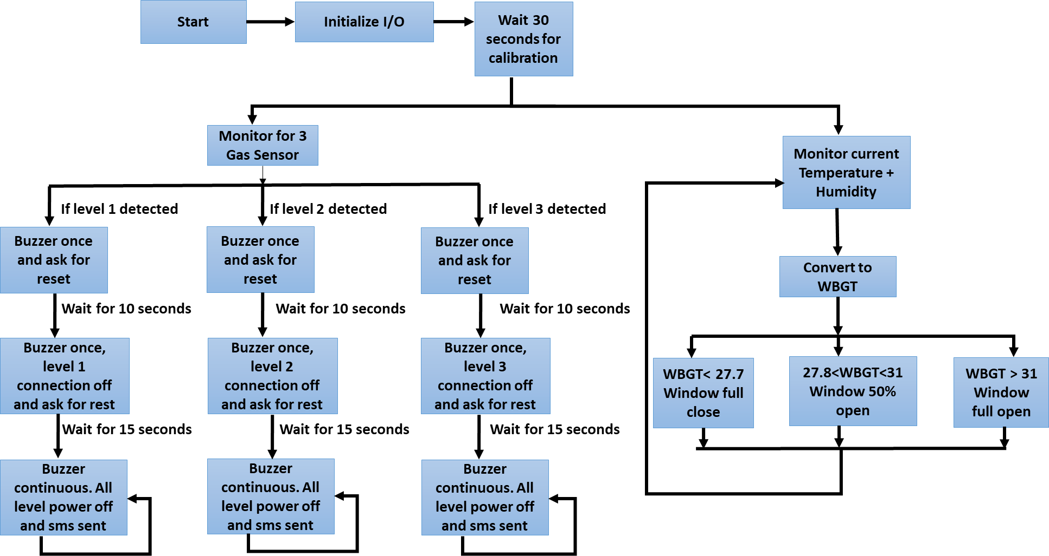

Figure 3.3.1 Conceptual Flow Chart

#### 3.4 Choice of Components

##### 3.4.1 Arduino UNO

The Arduino Uno is a microcontroller board based on the ATmega328. It has 14 digital input/output pins (of which 6 can be used as PWM outputs), 6 analog inputs, a 16 MHz ceramic resonator, a USB connection, a power jack, an ICSP header, and a reset button. It contains everything needed to support the microcontroller. To get it started simply connect it with a USB cable or power it an AC to DC adapter or battery.

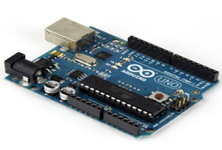

Figure 3.4.1 Arduino Uno

##### 3.4.2 DHT11

DHT11 is a temperature and humidity sensor. It features a temperature & humidity sensor complex with a calibrated digital signal output. By using the exclusive digital-signal-acquisition technique and temperature & humidity sensing technology, it ensures high reliability and excellent long-term stability. This sensor includes a resistive-type humidity measurement component and an NTC temperature measurement component and connects to a high performance 8-bit microcontroller, offering excellent quality, fast response, anti-interference ability and cost-effectiveness.

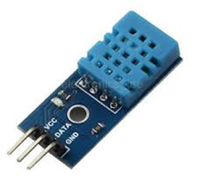

Figure 3.4.2 DHT11

##### 3.4.3 MQ5

The sensor has a sensitive filament made of SnO2. In the presence of clean air, this filament tends to have lower electrical conductivity. When a combustible gas such as LPG is introduced, the filament’s conductivity rises, and the amount of change in it’s conductance/resistance can be used to indicate the equivalent gas concentration. This effect tends to be particularly pronounced at higher temperatures, and resistive heating element is present as well. SnO2 is particularly sensitive to Methane, Butane and Propane, but is also sensitive to other combustible gases as well.

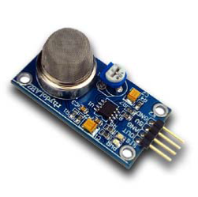

Figure 3.4.3 MQ5

##### 3.4.4 SIM900 GSM Module

The SIM900 is a complete Quad-band GSM/GPRS solution in a SMT module which can be embedded in the customer applications. Featuring an industry-standard interface, the SIM900 delivers GSM/GPRS 850/900/1800/1900MHz performance for voice, SMS, Data, and Fax in a small form factor and with low power consumption. With a tiny configuration of 24mm x 24mm x 3 mm, SIM900 can fit almost all the space requirements in your M2M application, especially for slim and compact demand of design.

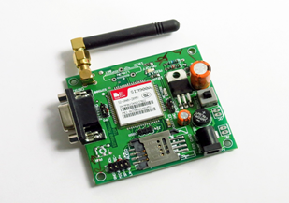

Figure 3.4.4 SIM900 GSM Module

##### 3.4.5 One Channel Relay Module

A relay is an electrically operated device. It is an automatic switch to controlling a high-current circuit with a low-current signal. It is widely adopted in devices of power protection, automation technology, sport, remote control, reconnaissance and communication, as well as in devices of electro mechanics and power electronics. A relay contains an induction part which can reflect input variable like current, voltage, power, resistance, frequency, temperature, pressure, speed and light etc. There is an intermediary part between input part and output part that is used to coupling and isolate input current, as well as actuate the output. When the rated value of input (voltage, current and temperature etc.) is above the critical value, the controlled output circuit of relay will be energized or de-energized.

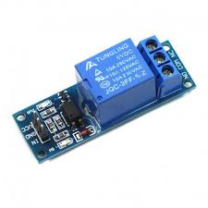

Figure 3.4.5 Relay Module

##### 3.4.6 Led

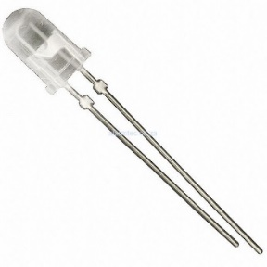

Figure 3.4.6 Led

##### 3.4.7 Servo sg90

Tiny and lightweight with high output power. Servo can rotate approximately 180 degrees (90 in each direction), and works just like the standard kinds but smaller. Any servo code, hardware or library can be used to control these servos. Good for beginners who want to make stuff move without building a motor controller with feedback & gear box, especially since it will fit in small places. It comes with a 3 horns (arms) and hardware.

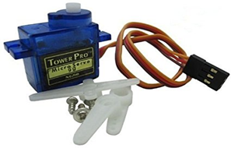

Figure 3.4.7 Servo sg90

##### 3.4.8 Buck Converter

A Buck converter is a switch mode DC to DC electronic converter in which the output voltage will be transformed to level less than the input voltage. It is also called as step down converter. The name step down converter comes from the fact that analogous to step down transformer the input voltage is stepped down to a level less than the input voltage.

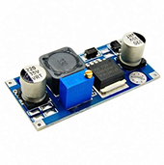

Figure 3.4.8 Buck Converter

##### 3.4.9 Voltage Regulator

A voltage regulator is an electricity regulation device designed to automatically convert voltage into a lower, usually direct current (DC), constant voltage.

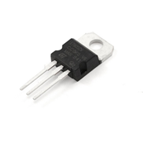

Figure 3.4.9 Voltage regulator

##### 3.4.10 Breadboard

A breadboard is a solder less device for temporary prototype with electronics and test circuit designs. Most electronic components in electronic circuits can be interconnected by inserting their leads or terminals into the holes and then making connections through wires where appropriate. The breadboard has strips of metal underneath the board and connect the holes on the top of the board. The metal strips are laid out as shown below. Note that the top and bottom rows of holes are connected horizontally and split in the middle while the remaining holes are connected vertically.

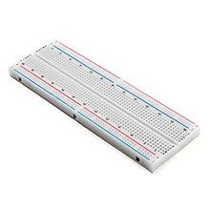

Figure 3.4.9 Breadboard

##### 3.4.11 LCD Display

LCD (Liquid Crystal Display) screen is an electronic display module and find a wide range of applications. A 16x2 LCD display is very basic module and is very commonly used in various devices and circuits. These modules are preferred over seven segments and other multi segment [LED](http://www.engineersgarage.com/content/led)s. The reasons being: LCDs are economical; easily programmable; have no limitation of displaying special & even custom characters (unlike in seven segments), animations and so on. A **16x2 LCD** means it can display 16 characters per line and there are 2 such lines. In this LCD each character is displayed in 5x7 pixel matrix. This LCD has two registers, namely, Command and Data.

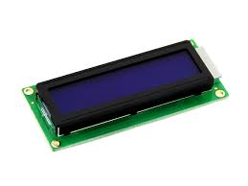

Figure 3.4.11 LCD Display

##### 3.4.12 9V 2Amp Adapter

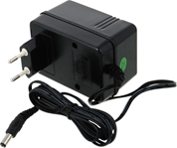

Figure 3.4.12 9V 2Amp Adapter

##### 3.4.12 Buzzer

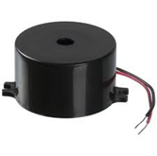

#### 3.5 Equivalent sensors used in Industries.

##### 3.5.1 Wireless Photoelectric Smoke Detector with Heat Detection

1. Automatic drift compensation
2. Built-in, dual-sensor heat detector with fixed heat and rate of rise.
3. Built-in 85dB horn
4. Local test button
5. Low profile design
6. High/Low sensitivity reporting
7. Low battery indication
8. Easy-maintenance removable smoke chamber
9. Long-life lithium batteries included
10. Reliable 433 MHz and 868 MHz technology.

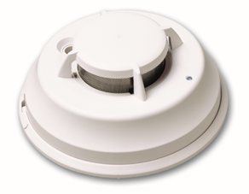

Figure3.5.1 Wireless Photoelectric Smoke Detector with Heat Detection

##### 3.5.2 Socket with industrial relay

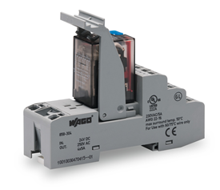WAGO's DIN-35-rail-mount 858 Series Relay Sockets are designed for conventional industrial relays with standard pin spacing. The sockets carry 33.5 to 35.5 mm-high relays equipped with two or four changeover contacts. All socket contacts feature two conductor entries at each Push-in CAGE CLAMP® COMPACT connection point for either 2 x 0.34 mm² (22 AWG) to 1.5 mm² (16 AWG) or 1 x 2.5 mm² (12 AWG) cross-section. Push-in cage clamp compact spring pressure connection technology provides simple, push-in termination of solid or ferruled conductors 0.5 mm² (20 AWG) and larger. Speedy socket service: rapidly replace relays without removing conductors.

Figure 3.5.2 Socket with industrial relay

##### 3.5.3 Humidity and temperature sensor

This instrument is capable of measuring in the range of 5 to 95 %RH, 0 to +50°C for the ambient model, -20 to +80°C for the duct mount version and -20 to +80°C for the remote variant. The cases is crafted from IP 65 for the duct and remote models and IP 20 for the ambient versions. This device can be ordered without or with a 10 digits LCD display and a 4-20 mA or 0-10 V output. Mounting is easy with a simplified housing and mounting interface. This temperature and humidity sensor can be had with either DIP switch configuration or software, and mounting is made easy with a wall mount plate to be used with a 1/4 turn system.

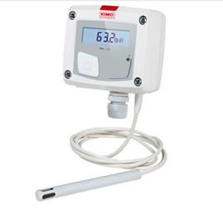

Figure 3.5.3 Humidity and temperature sensor

#### 3.6 Modelling WGBT Solution.

* WBGT (Wet-Bulb Globe temperature) method is used to determine the level of heat stress.WBGT is important throughout the year, but it is especially important when it comes to preventing heat-related injuries and illness for workers working in industries.
* **Why is heat a hazard to workers?**
* When a person works in a hot environment, the body must get rid of excess heat to maintain a stable internal temperature. It does this mainly through circulating blood to the skin and through sweating.

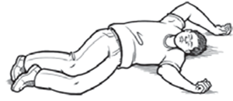

* When the air temperature is close to or warmer than normal body temperature, cooling of the body becomes more difficult. Blood circulated to the skin cannot lose its heat. Sweating then becomes the main way the body cools off. But sweating is effective only if the humidity level is low enough to allow evaporation, and if the fluids and salts that are lost are adequately replaced.
* If the body cannot get rid of excess heat, it will store it. When this happens, the body's core temperature rises and the heart rate increases. As the body continues to store heat, the person begins to lose concentration and has difficulty focusing on a task, may become irritable or sick, and often loses the desire to drink. The next stage is most often fainting and even death if the person is not cooled down.
* Excessive exposure to heat can cause a range of [heat-related illnesses](https://www.osha.gov/SLTC/heatstress/heat_illnesses.html), from heat rash and heat cramps to heat exhaustion and heat stroke. Heat stroke can result in death and requires immediate medical attention.
* Exposure to heat can also increase the risk of injuries because of sweaty palms, fogged-up safety glasses, dizziness, and burns from hot surfaces or steam.
* WBGT is based on an equation where a combination of environmental factors are used to calculate a reading.  The calculation used measures the heat stress in direct sunlight.  This type of reading also takes into account:

1. Temperature
2. Wind speed
3. Humidity
4. The angle of the sun
5. Solar radiation

This isn’t the same as what is called the “heat index”, which is just the temperature and humidity, as calculated for shady areas.

* **Algorithm for measuring WBGT:**

The algorithm for measuring WBGT are as follows:

* The values to be entered are wind speed (u in meters per hour), ambient temperature (Ta in degrees Celsius), dew point temperature (Td in degrees Celsius), solar irradiance (S in Watts per meter squared), direct beam radiation from the sun (𝑓𝑑𝑏) and diffuse radiation from the sun (𝑓𝑑𝑖𝑓).

The approximated values are:

Wind speed: 1mph

Solar irradiance: 800W/m2

The dew point temperature is calculated using the formula:

Td=ta-((100-relative humidity)/5);

* The zenith angle(z) is taken to be 45 degree
* The thermal emissivity must be calculated next. Using the following two equations:

𝑒𝑎=exp(17.67(𝑇𝑑−𝑇𝑎)𝑇𝑑+243.5)×(1.0007+0.00000346𝑃)×6.112exp(17.502𝑇𝑎/240.97+𝑇𝑎)

𝜀𝑎=0.575𝑒(17⁄)

* Now B and C can be calculated using the following equations.

a. 𝐵=𝑆 (𝑓𝑑𝑏/4𝜎cos (𝑧) + (1.2𝜎)𝑑𝑖𝑓)+(𝜀𝑎)𝑇𝑎4, where 𝜎 =5.67×10-8

b. 𝐶=ℎ𝑢0.58 (5.3865×10−8), where *h*=0.315

* Finally the estimate for globe temperature is calculated using equation (10).

𝑇𝑔=𝐵+𝐶𝑇𝑎+7680000

* Temperature and humidity sensor is used to measure air temperature and relative humidity
* The WBGT-index combines three measurements:
  + - 1. Natural wet-bulb temperature (tnw)
      2. Globe temperature (tg)
      3. Air temperature (ta)
* The WBGT indoor and outdoor are calculated as:

WBGT indoor = 0.7tnw + 0.3tg

WBGT outdoor = 0.7tnw +0.2tg +0.1ta

* **Block diagram of WBGT model:**

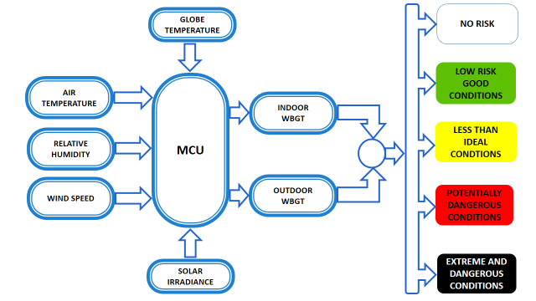

Figure 3.6.1 Block diagram of WBGT

* **Changes in ventilation with WBGT heat stress:**

Windows are opened and closed depending upon WBGT reading.

Due to limitation of servo motor we are considering three range of WBGT values which are shown according to the block diagram as follow:

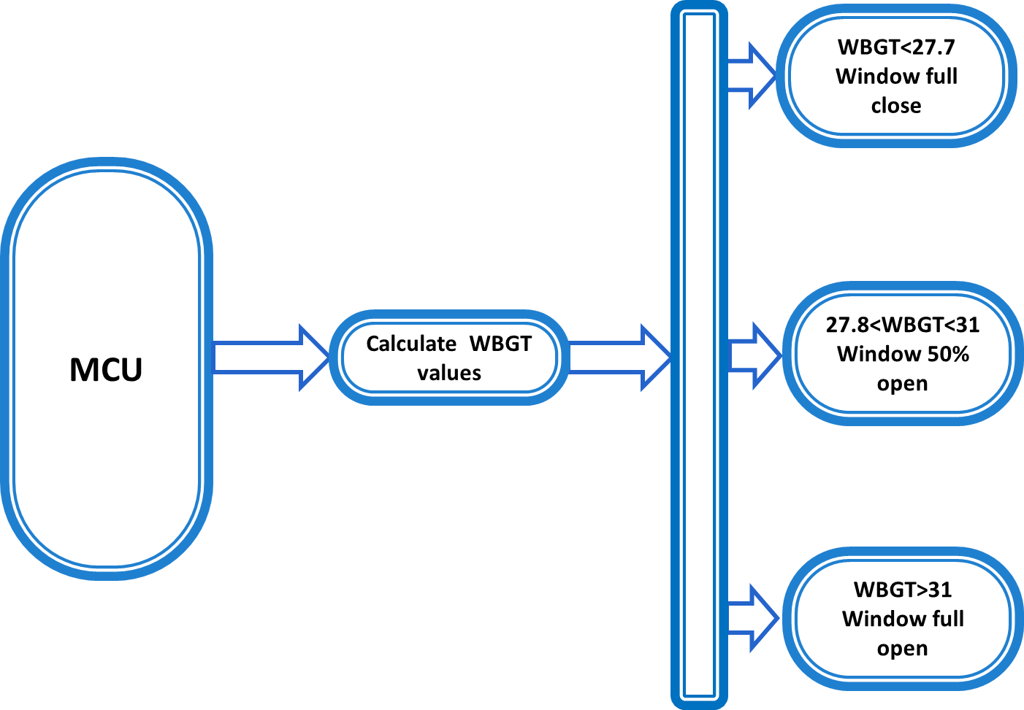

Figure 3.6.2 Customized block diagram of WBGT

#### 3.7 System Features.

After a lot of considerations and thinking the final set of features that will be provided in the project are:

1. Fire and gas sensors- When the temperature of the room goes above the threshold level or unwanted gas is detected in the room the sensors will be triggered.
2. Alarm and message alert system- As soon as the sensors are triggered the alarm will be turned on and the message will be sent to the nearest fire brigade and the authority.
3. Selective disengage and specified Time out system- When the sensors detect something than alarm will be shown just in the control center. A time out of 10 seconds will be provided for manually reset or to investigate the problem. Once it is configured from which floor it is coming from, the power to that floor is disconnected using relay. Again, a timeout of 15 seconds is provided for manual override. If the reset button is not used within this period than the power to the whole building is cut out.
4. Trail of light for emergency- When the main power is shutdown, a trail of light which is powered by backup battery is provided so that the workers trapped in the room can get a clear route to the exit door.
5. The values of the sensors will be shown in a 16x2 LCD screen- The near to accurate values of the temperature, humidity and Wbgt is shown in a LCD screen.
6. The graphs of the temperature, humidity and WBGT level will also be shown-
7. Use of WBGT to measure heat stress- The current values of the temperature and humidity that are recorded are put in an algorithm to calculate the current Wbgt of the room. If current values exceed the already recorded values of the Wbgt than ventilation will be provided.
8. Ventilation provided with respect to the temperature and humidity inside the room- What percentage of the window will open depends on the readings that will be shown on the LCD screen.

## Chapter 4

### Performance Estimates and Evaluation

#### 4.1 Serial Monitor Sensor Logs

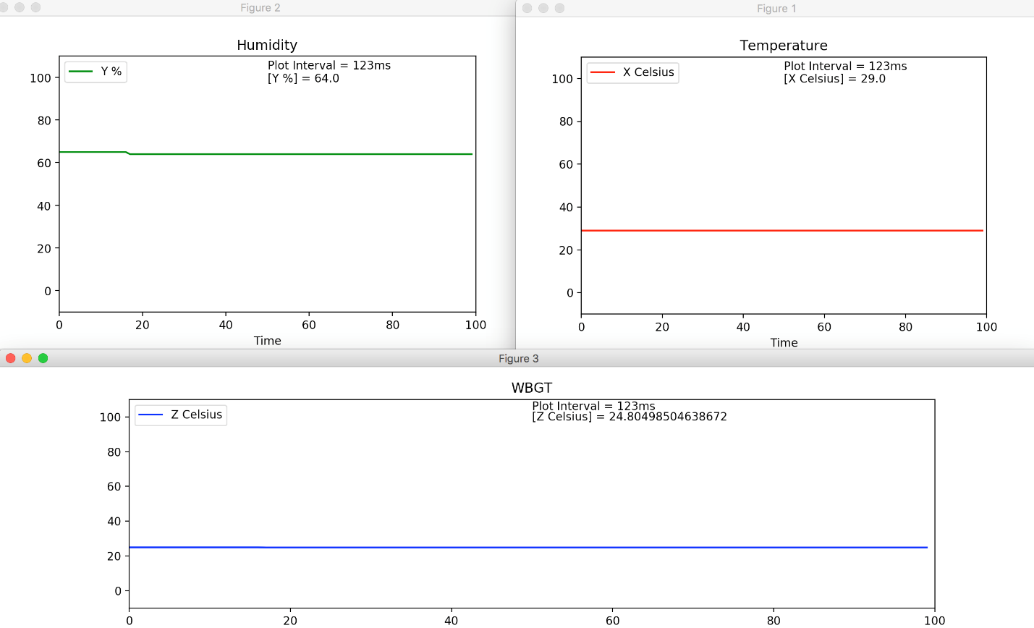

Figure 4.1.1 Graphical View

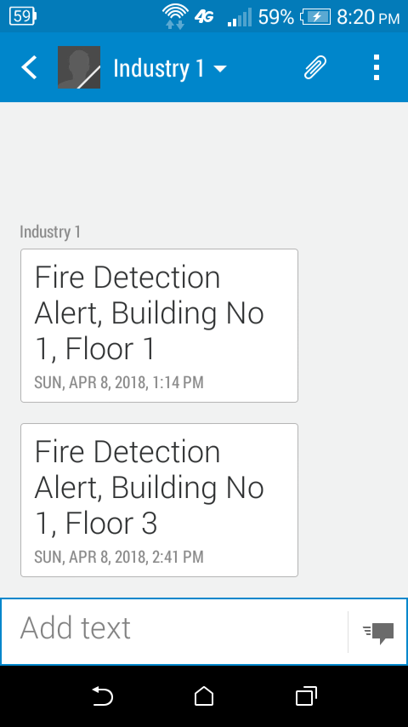

#### 4.2 WGBT Verification

WBGT calculation is verified in MATLAB which are shown below:

Climate CHIP is a non-profit website supported by charitable grants from organizations and individuals concerned about local and global threats to human health and society from climate change. They aim to provide a range of information and resources about heat stress and other health impacts of climate change. We have verified our WBGT values from their website which that our values closely matches with their values.

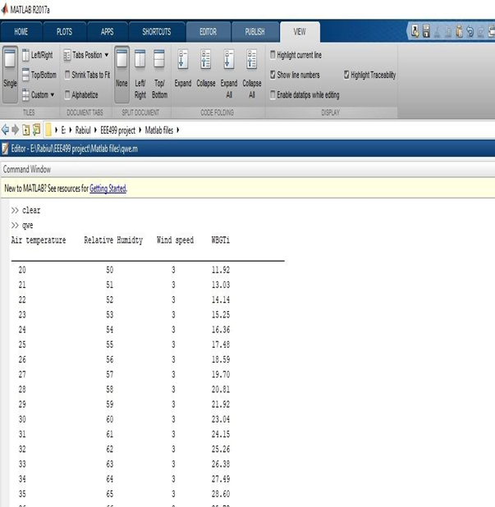

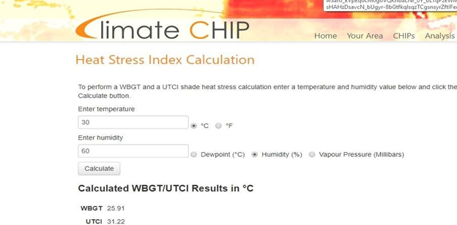

We have entered for temperature 30oC and humidity of 60%. It gives the WBGT value of 25.91 whereas our model of WBGT gives 23.04 which is pretty close.

## Chapter 5

### Design Impact

#### 6.1 Professional Concerns

The design was performed with input from various sources and we have strived our best to include the references to those in our reports. Code of Ethics for Engineers (http://www.niee.org/) specifies that it is required honesty, equity, impartiality and dedication to health protection, safety and public welfare to any  
researcher our project. The main four principles that stay at the basis of any research activity are: the respect for human dignity, the utility of a project, the precaution against risks that might affect the safety, health and social welfare and the justice.

However, we reserve the right to all our computer codes including but not limited to Arduino code, MATLAB code and lastly processing code.

#### 6.2 Societal Impact

The project aims to create a profound impact on the general safety and health aspect of industrial workers in Bangladesh. The project aims to readily provide not only an alarm system for fire safety but also to monitor the heat stress of the worker. Hence this should in theory provide opportunity to improve on existing working condition and thereby the welfare of the workers.

#### 6.3 Cost and Economic Evaluation

Our ideas although geared towards large scale industry could be readily deployed to small business as well. Thus, we have emphasized greatly on reducing the cost of our components both in the prototype and in an industrial scenario. This should mean that it is affordable to other small business as well who could greatly benefit from this.

An estimate of our total cost has been provided in the Appendix section of this report. The total cost has been found to be around the ballpark of Tk 6910. It must be known that the final cost could vary but we have shied away from displaying a more conservative estimate in order to be more transparent.

A key part of our project has been to drive widescale adoption and low cost coupled with ease of use and accessibility should ensure that it reaches our aim.

## Chapter 6

### Discussion and Feedback

Throughout the project in different phases we have been in constant touch without faculty advisor Dr Mahdy Rahman Chowdhury and worked upon the feedback he has given us.

We also would like to thank our classmates who have provided valuable advice on some approach and regarding the execution of the project ranging from a number of factors such as developing a prototype model and its feasibility.

We have also visited several RMG (Readymade garments) and various other small technical business to have a better understanding of the current condition and how our project could be improved.

We are also delighted to say that at the point of penning this report (18th April 2018) we are in advanced stage of negotiating with a certain ready garment garments factory to implement a testing of our prototype. We are greatly looking forward to the co-operation and hope that we would be able to further develop our product and meet the challenges that arises in a realistic scenario.

### Limitations

A key limitation in our project has been the demonstration of our prototype. We believe our readers are by this point well aware that the exact WGBT readings are not possible to be demoed by our mockup model. As mentioned we have modified our true WGBT value.

We intend to further fine tune our modeling to make it as close as possible with the original WGBT values as mentioned by OSHA (Occupational Safety Hazard Authority)

### Future Work

Due to time constraints and several other issues we were not able to fully materialize our objectives. As part of additional work, we wanted to connect the emergency exit doors electronically to synchronize with the alarm. At the same time, we have to ensure a failsafe system that can unlatch the exit door mechanically in case there is a failure in our system.

We also aim to further develop a comprehensive software solution that can not only not only provide a graphic interface monitoring panel but also enable remote switching of the systems.

## Conclusion

It has been a great endeavor for us from the inception of our project leading to its prototype phase. Throughout the journey we have encountered

We have strived to devise a cost-effective solution by devising a model that can integrate various safety features into an all-in-one package. There have rarely been any solutions in our country that offers the same concept as ours.

Thus, the primary goal of our project was to present a prototype model based on our conceptual idea of an integrated industrial monitoring system. Despite the limitations of our mockup we have successfully demonstrated the proposed features. In real life scenario further tuning of WBGT measurements using our algorithm should help us to achieve our goal. We strongly believe that large scale implementation of our project in the wider industry of this country could bring a considerable positive change in working condition of workers in vital industry such as RMG.

# References

1. Shumi, A. (2018). Fire safety in garments industry: Design matters. [online] The Daily Star. Available at: <http://www.thedailystar.net/news-detail-43117> [Accessed 19 Apr. 2018].
2. Wadud, Z., Huda, F. and Ahmed, N. (2018). Assessment of Fire Risk in the Readymade Garment Industry in Dhaka, Bangladesh.
3. The Conversation. (2018). Five years after deadly factory fire, Bangladesh's garment workers are still vulnerable. [online] Available at: <https://theconversation.com/five-years-after-deadly-factory-fire-bangladeshs-garment-workers-are-still-vulnerable-88027> [Accessed 19 Apr. 2018].
4. U.S. (2018). Factbox: Major industrial accidents in Bangladesh in recent years. [online] Available at: <https://www.reuters.com/article/us-bangladesh-blast-accidents-factbox/factbox-major-industrial-accidents-in-bangladesh-in-recent-years-idUSKBN19P0JN> [Accessed 10 Apr. 2018].
5. [https://www.solidaritycenter.org/wp-content/uploads/2016/04/Bangladesh.Garment-Textile-Factory-Fire-Incidents-since-Tazreen.04.16.pdf+&cd=6&hl=en&ct=clnk&gl=bd](https://webcache.googleusercontent.com/search?q=cache:T8ZHcj-pANEJ:https://www.solidaritycenter.org/wp-content/uploads/2016/04/Bangladesh.Garment-Textile-Factory-Fire-Incidents-since-Tazreen.04.16.pdf+&cd=6&hl=en&ct=clnk&gl=bd) [Accessed 10 Apr. 2018].
6. Nuclear accidents worldwide from 1957 to 2011, r. (2018). Nuclear accidents worldwide - INES scale 2011 | Statistic. [online] Statista. Available at: <https://www.statista.com/statistics/273002/the-biggest-nuclear-accidents-worldwide-rated-by-ines-scale/> [Accessed 14 Apr. 2018].
7. Chowdhury, S. (2018). Solar Power Potentiality Analysis in Some Regions of Bangladesh in the Case of Solar Irradiance. [online] Pubs.sciepub.com. Available at: <http://pubs.sciepub.com/joe/2/2/5/index.html> [Accessed 21 Apr. 2018].
8. Chowdhury, S. (2018). Solar Power Potentiality Analysis in Some Regions of Bangladesh in the Case of Solar Irradiance. [online] Pubs.sciepub.com. Available at: <http://pubs.sciepub.com/joe/2/2/5/index.html> [Accessed 21 Apr. 2018].
9. Hossain, M. M., Lau, B., Wilson, R., & Ford, B. (2017). Effect of changing window type and ventilation strategy on indoor thermal environment of existing garment factories in Bangladesh. Architectural Science Review, 60(4), 299-315.
10. <https://www.osha.gov/dts/osta/otm/otm_iii/otm_iii_4.html> [Retrieved 17/02/2018]
11. Chowdhury, S., Hamada, Y., & Ahmed, K. S. (2017). Prediction and comparison of monthly indoor heat stress (WBGT and PHS) for RMG production spaces in Dhaka, Bangladesh. Sustainable Cities and Society, 29, 41-57
12. Batsungnoen, Kiattisak & Kulworawanichpong, Thanatchai. (2012). Heat Stress Monitor by using Low cost Temperature and Humidity Sensors

# Appendix B: Prototype of the Project

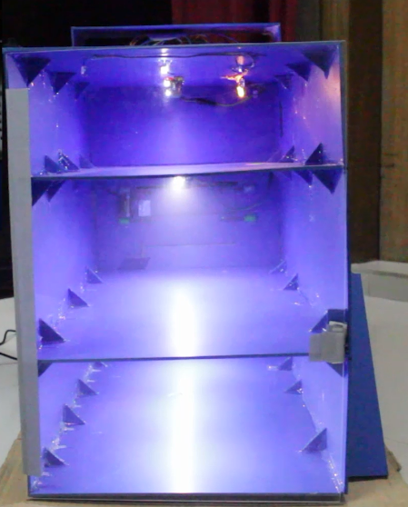

Figure 7.1 Front side

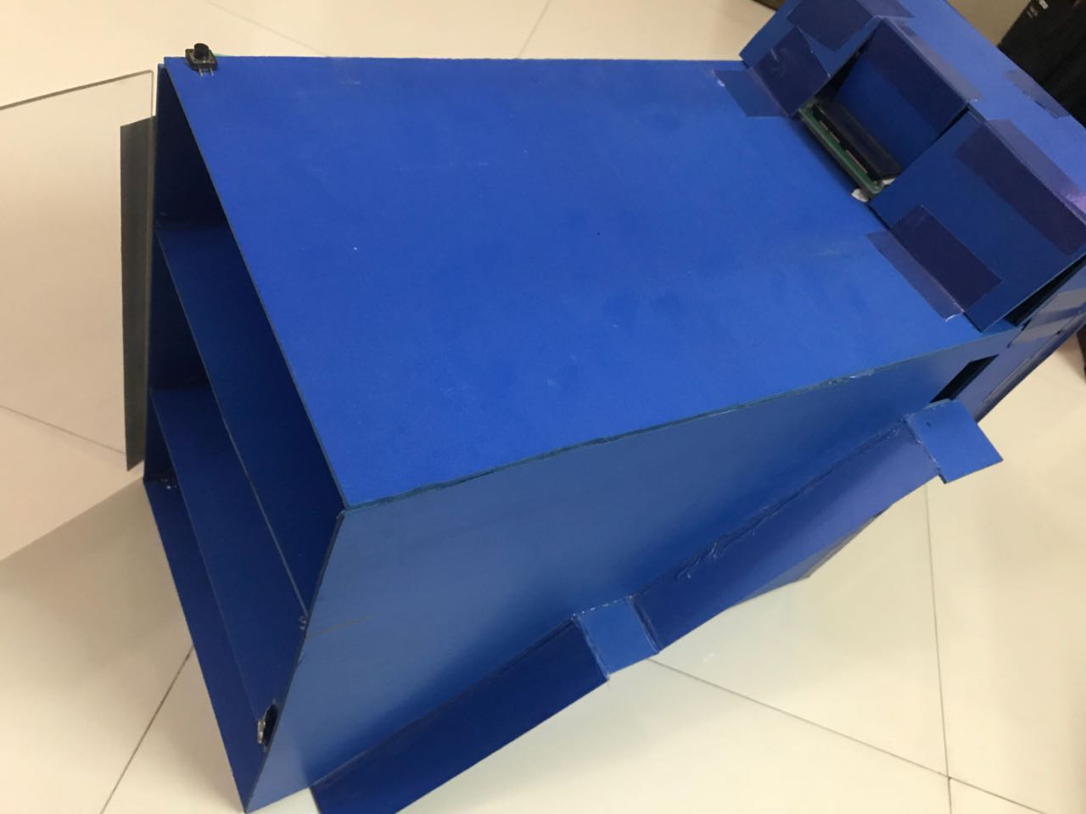

Figure 7.2 Top view

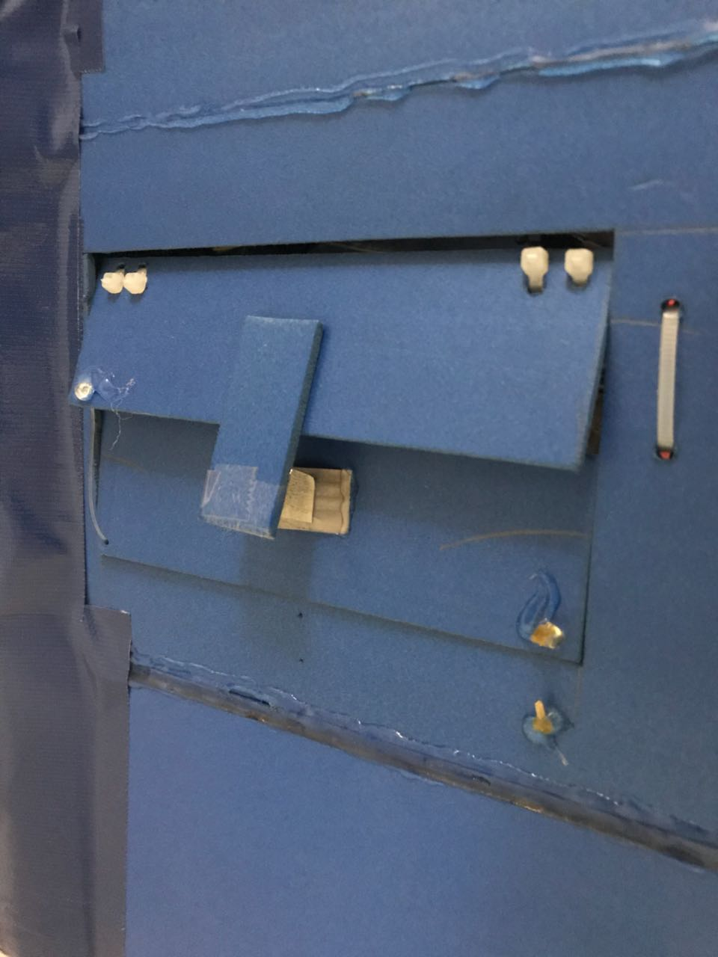

Figure 7.3 Back side

# Appendix C: List of Figures

Page

1. Figure2.1.1 Clear width of an exit corridor reduced by piled up boxes ...................................... 13
2. Figure 2.1.2 Death and Injured due to due to Fire, False Alarm and Gas leakage.................... 16
3. Figure 3.4.1 Arduino Uno ............................................................................................................ 24
4. Figure 3.4.2 DHT11 ...................................................................................................................... 24
5. Figure 3.4.3 MQ5 ......................................................................................................................... 25
6. Figure 3.4.4 SIM900 GSM Module .............................................................................................. 26
7. Figure 3.4.5 Relay Module ........................................................................................................... 26
8. Figure 3.4.6 Led ............................................................................................................................ 27
9. Figure 3.4.7 Servo sg90 ................................................................................................................ 27
10. Figure 3.4.8 Buck Converter ......................................................................................................... 28
11. Figure 3.4.9 Voltage regulator ..................................................................................................... 28
12. Figure 3.4.10 Breadboard ….......................................................................................................... 29
13. Figure 3.4.11 LCD Display ............................................................................................................. 29
14. Figure 3.4.12 9V 2Amp Adapter ................................................................................................... 30
15. Figure 3.4.14 Buzzer ..................................................................................................................... 30
16. Figure 3.5.1 Wireless Photoelectric Smoke Detector with Heat Detection ................................ 31
17. Figure 3.5.2 Socket with industrial relay ...................................................................................... 31
18. Figure 3.5.3 Humidity and temperature sensor .......................................................................... 32
19. Figure 3.6.1 Block diagram of WBGT ........................................................................................... 36
20. Figure 3.6.2 Customized block diagram of WBGT ....................................................................... 37
21. Figure 4.1.1 Graphical View……………………………………………………………………………………………………. 40
22. Figure 4.2.1 Heat Stress Index Calculation ………………………………………………………………………....... 44
23. Figure 7.1 Front view ………………………………………………………………………………………………............... 56
24. Figure 7.2 Top view …………………………………………………………………………………………………………….... 56
25. Figure 7.3 Back view ………………………………………………………………………………………………………………. 57

# Appendix D: List of Tables

# Appendix E: MATLAB Code

% Globe temperature Calculation  
clear all  
symstgBCuta                    %tg=globe temperature,B and C are constant,u is wind speed, ta is air temperature  
symstdeaems                      %td is dew point temperature, ea is atmospheric vapor pressure,ems is thermal emmisivity  
symsWBGTiWBGTotnwRHdp_dep      %WBGTi is indoor WBGT temperature,WBGTo is outdoor WBGT temperature  
                                %tnw is wet-bulb temperature, RH is relative humidity, dp_dep is dew point depression

%prompt='Enter the value of air temperature in celsius:\n'  
%ta=input(prompt)

%prompt= ('Enter the value of relative humidity:\n')  
%RH=input(prompt)

%prompt='Enter the value of wind speed in mph:\n'  
%u=input(prompt)  
  
fprintf('Air temperature     Relative Humidty Wind speed     WBGTi\n');  
  
  
  
fprintf('___________________________________________________________________________\n')

c=-25;  
u=3;  
ta=20;  
RH=50;  
while c<=0  
td=ta-((100-RH)/5);  
  
  
x=101.155e6;  
ea=exp((17.67*(td-ta))/(td+243.5))*8.3*exp((17.502*ta)/(240.97+ta));  
ems = 0.575*ea^(1/7);  
C=((0.315*(u^0.58))/5.3865e-8);  
B = x+ems*(ta)^4;  
tg=(B+C*ta+7680000)/(C+256000);  
  
%WBGT calculation  
  
td=ta-((100-RH)/5);  
dp_dep = ta-td;  
s=(dp_dep)/1.2;  
tnw=ta-s;  
  
  
  
  
  
  
WBGTi=(0.7*tnw+0.3*tg)-5;  
WBGTo = 0.7*tnw+0.2*tg+0.1*ta;  
  
  
  
  
fprintf('  %d                     %d %d      %.2f\n',ta,RH,u,WBGTi);  
  
    ta=ta+1;  
    RH=RH+1;  
    c=c+1;  
  
end

# Appendix F: ARDUINO Code

#include <SoftwareSerial.h>

#include <LiquidCrystal.h>

#include <dht.h>

#include <Servo.h>

Servo myservo;

int u=30;

float td;

float x=101.155*pow(2.71,6);

floatea;

float ems;

float C;

float B;

floattg;

floatdp_dep;

float s;

floattnw;

floatWBGTi;

floatWBGTo;

SoftwareSerialmySerial(7, 8);

dht DHT;

//************************************************

int sensitivity=100; //gas sensitivity

int timeout1=10;

int timeout2=15;

//************************************************

#define DHT11_PIN 18

int gasvalue1=0;

int gasvalue2=0;

int gasvalue3=0;

int set1;

int set2;

int set3;

int count1=timeout2;

int count2=timeout2;

int count3=timeout2;

int buzzer=9;

int relay1=10;

int relay2=11;

int relay3=12;

LiquidCrystallcd(2,3,4,5,6,17);

void setup()

{

Serial.begin(9600);

mySerial.begin(9600);

myservo.attach(19);

myservo.write(30); //WINDOW CLOSE

lcd.begin(16,2);

lcd.setCursor(0,0);

pinMode(9,OUTPUT);

pinMode(10,OUTPUT);

pinMode(11,OUTPUT);

pinMode(12,OUTPUT);

digitalWrite(relay1,LOW);

digitalWrite(relay2,LOW);

digitalWrite(relay3,LOW);

lcd.print("*****Welcome****");

lcd.setCursor(0,1);

lcd.print("Calibrating.....");

delay(3000);

set1=analogRead(A0);

set2=analogRead(A1);

set3=analogRead(A2);

}

void loop(){

DHT.read11(DHT11_PIN);

lcd.clear();

lcd.setCursor(0,0);

lcd.print("T:");

lcd.print(DHT.temperature,0);

lcd.print((char)223);

lcd.print("C");

lcd.print(" H:");

lcd.print(DHT.humidity,0);

lcd.print("%");

float ta=DHT.temperature;

float RH=DHT.humidity;

td=(ta-(100-RH)/5);

ea=exp((17.67*(td-ta))/(td+243.5))*8.3*exp((17.502*ta)/(240.97+ta));

ems= 0.575*pow(ea,(1/7));

C=((0.315*(pow(u,0.58)))/5.3865e-8);

B = x+ems*pow((ta),4);

tg=(B+C*ta+7680000)/(C+256000);

td=ta-((100-RH)/5);

dp_dep = ta-td;

s=(dp_dep)/1.2;

tnw=ta-s;

WBGTi=0.7*tnw+0.3*tg;

WBGTo = 0.7*tnw+0.2*tg+0.1*ta;

//Serial.print("WBGT Indoor: ");

Serial.print(DHT.temperature);

Serial.print(",");

Serial.print(DHT.humidity);

Serial.print(",");

Serial.println(WBGTi);

//Serial.print(" WBGT Outdoor: ");

//Serial.println(WBGTo);

lcd.setCursor(0,1);

lcd.print("WBGTi: ");

lcd.print(WBGTi);

//******************************************************

if(WBGTi<27.7){

myservo.write(30); //WINDOW CLOSE

}

else if(WBGTi>27.8 &&WBGTi<31){

myservo.write(100); //WINDOW 50%

}

else if(WBGTi>31.5){

myservo.write(160); //WINDOW FULL OPEN

}

//********************************************************

gasvalue1=analogRead(A0);

gasvalue2=analogRead(A1);

gasvalue3=analogRead(A2);

if(gasvalue1>set1+sensitivity){

lcd.setCursor(0,1);

lcd.print("Level 1 Smoke ");

level1();

}

if(gasvalue2>set2+sensitivity){

lcd.setCursor(0,1);

lcd.print("Level 2 Smoke ");

level2();

}

if(gasvalue3>set3+sensitivity){

lcd.setCursor(0,1);

lcd.print("Level 3 Smoke ");

level3();

}

delay(5000);

}

void level1(){

count1=timeout1;

digitalWrite(buzzer,HIGH);

while(1){

lcd.clear();

lcd.setCursor(0,0);

lcd.print("Level 1 Alarm!!!");

lcd.setCursor(0,1);

lcd.print("Cancel?");

lcd.print(count1);

count1=count1-1;

delay(1000);

digitalWrite(buzzer,LOW);

if (count1==0) level1p2();

}

}

void level1p2(){

//cut off relay 1

digitalWrite(relay1,HIGH);

count1=timeout2;

digitalWrite(buzzer,HIGH);

while(1){

lcd.clear();

lcd.setCursor(0,0);

lcd.print("Level 1 Power off");

lcd.setCursor(0,1);

lcd.print("Cancel?");

lcd.print(count1);

count1=count1-1;

delay(1000);

digitalWrite(buzzer,LOW);

if (count1==0) phase3();

}

//-------------------------------------------------------------

}

void level2(){

count2=timeout1;

digitalWrite(buzzer,HIGH);

while(1){

lcd.clear();

lcd.setCursor(0,0);

lcd.print("Level 2 Alarm!!!");

lcd.setCursor(0,1);

lcd.print("Cancel?");

lcd.print(count2);

count2=count2-1;

delay(1000);

digitalWrite(buzzer,LOW);

if (count2==0) level2p2();

}

}

void level2p2(){

//cut off relay 1

digitalWrite(relay2,HIGH);

count2=timeout2;

digitalWrite(buzzer,HIGH);

while(1){

lcd.clear();

lcd.setCursor(0,0);

lcd.print("Level 2 Power off");

lcd.setCursor(0,1);

lcd.print("Cancel?");

lcd.print(count2);

count2=count2-1;

delay(1000);

digitalWrite(buzzer,LOW);

if (count2==0) phase3();

}

}

//----------------------------------------------------

void level3(){

count3=timeout1;

digitalWrite(buzzer,HIGH);

while(1){

lcd.clear();

lcd.setCursor(0,0);

lcd.print("Level 3 Alarm!!!");

lcd.setCursor(0,1);

lcd.print("Cancel?");

lcd.print(count3);

count3=count3-1;

delay(1000);

digitalWrite(buzzer,LOW);

if (count3==0) level3p2();

}

}

void level3p2(){

//cut off relay 1

digitalWrite(relay3,HIGH);

count3=timeout2;

digitalWrite(buzzer,HIGH);

while(1){

lcd.clear();

lcd.setCursor(0,0);

lcd.print("Level 3 Power off");

lcd.setCursor(0,1);

lcd.print("Cancel?");

lcd.print(count3);

count3=count3-1;

delay(1000);

digitalWrite(buzzer,LOW);

if (count3==0) phase3();

}

}

void phase3(){

//full power off

if(count1==0){

sms();

}

if(count2==0){

sms1();

}

if(count3==0){

sms2();

}

while(1){

digitalWrite(relay1,HIGH);

digitalWrite(relay2,HIGH);

digitalWrite(relay3,HIGH);

lcd.clear();

lcd.setCursor(0,0);

lcd.print("Full Power off ");

//sms sent

digitalWrite(buzzer,HIGH);

delay(200);

}

}

voidsms(){

mySerial.print("\r");

delay(1000);

mySerial.print("AT+CMGF=1\r");

delay(1000);

mySerial.print("AT+CMGS=\"+8801627143179\"\r");

delay(1000);

mySerial.print("Fire Detection Alert, Building No 1, Floor 1");

delay(1000);

mySerial.write(0x1A);

}

void sms1(){

mySerial.print("\r");

delay(1000);

mySerial.print("AT+CMGF=1\r");

delay(1000);

mySerial.print("AT+CMGS=\"+8801627143179\"\r");

delay(1000);

mySerial.print("Fire Detection Alert, Building No 1, Floor 2");

delay(1000);

mySerial.write(0x1A);

}

void sms2(){

mySerial.print("\r");

delay(1000);

mySerial.print("AT+CMGF=1\r");

delay(1000);

mySerial.print("AT+CMGS=\"+8801627143179\"\r");

delay(1000);

mySerial.print("Fire Detection Alert, Building No 1, Floor 3");

delay(1000);

mySerial.write(0x1A);

}

# Appendix G: Processing Code

importprocessing. Serial.*;

Serial myPort;

intnumValues = 3;

float[] values = new float[numValues];

int[] min = new int[numValues];

int[] max = new int[numValues];

color[] valColor = new color[numValues];

floatpartH;

intxPos = 0;

booleanclearScreen = true;

void setup() {

size(1600, 750);

partH = height / numValues;

printArray(Serial.list());

String portName = Serial.list()[1];

myPort = new Serial(this, portName, 9600);

myPort.bufferUntil('\n');

textSize(20);

background(0);

noStroke();

values[0] = 0;

min[0] = 0;

max[0] = 50;

valColor[0] = color(255, 0, 0); // red

values[1] = 0;

min[1] = 0;

max[1] = 100;

valColor[1] = color(0, 255, 0);

values[2] = 0;

min[2] = 0;

max[2] = 50;

valColor[2] = color(0, 0, 255); // blue

/*

// example for adding a 4th value:

values[3] = 0;

min[3] = 0;

max[3] = 400;

valColor[3] = color(255, 0, 255); // purple

*/

}

void draw() {

moves

)

if (clearScreen) {

background(0);

fill(0,200);

noStroke();

rect(0,0,width,height);

clearScreen = false; // reset flag

}

for (inti=0; i<numValues; i++) {

floatmappedVal = map(values[i], min[i], max[i], 0, partH);

// draw lines:

stroke(255);

line(xPos, partH*(i+1)- mappedVal, xPos, partH*(i+1)- mappedVal );

// draw dividing line:

stroke(255);

line(1, partH*(i+1), width, partH*(i+1));

// display values on screen:

fill(50);

noStroke();

rect(0, partH*i+1, 250, 25);

fill(255);

text(round(values[i]), 2, partH*i+20);

fill(125);

text(max[i], 40, partH*i+20);

text("Temperature:", 100,20);

text("Humidity:", 100,270);

text("WBGT:", 100,520);

//print(i + ": " + values[i] + "\t");

//println("\t"+mappedVal);

}

//println();

xPos++;

if (xPos> width) {

xPos = 0;

clearScreen = true;

}

//drawGrid();

delay(50);

}

voidserialEvent(Serial myPort) {

try {

String inString = myPort.readStringUntil('\n');

//println("raw: \t" + inString);

if (inString != null) {

// trim off any whitespace:

inString = trim(inString);

values = float(splitTokens(inString, ", \t"));

// if the array has at least the # of elements as your # of sensors, you know

// you got the whole data packet.

if (values.length>= numValues) {

/* you can increment xPos here instead of in draw():

xPos++;

if (xPos> width) {

xPos = 0;

clearScreen = true;

}

*/

}

}

}

catch(RuntimeException e) {

e.printStackTrace();

}

}

voiddrawGrid() {

fill(254);

stroke(224);

strokeWeight(1);

// drawing of 10 lines

for (int row = 0; row < 20; row++) {

line(row * (width/20), height-0, row * 80, 0);

}

}

# Appendix H: Bill of Materials

|  |  |  |
| --- | --- | --- |
| Component | Quantity | Cost(BDT) |
| Arduino Uno | 2 | 1000 |
| Gas Sensor | 3 | 600 |
| DHT 11 |  | 200 |
| Servo sg90 |  | 180 |
| Voltage Regulator |  | 15 |
| Sim900 sm module |  | 2200 |
| Led white & yellow |  | 50 |
| Buck Converter |  | 150 |
| Lcd Display |  | 200 |
| Breadboard |  | 110 |
| 9V 2Amp Adapter | 2 | 300 |
| 1 channel relay module | 3 | 250 |
| Buzzer |  | 25 |
| Magnet |  | 80 |
| Jumper wires |  | 150 |
| Pvc Sheet |  | 1000 |
| Arylic |  | 400 |
|  | Total | 6910 |

1. **:**Chowdhury, S., Hamada, Y. and Ahmed, K. (2017). Prediction and comparison of monthly indoor heat stress (WBGT and PHS) for RMG production spaces in Dhaka, Bangladesh. *Sustainable Cities and Society*, 29, pp.41-57